Content Matrix Template: Applicable for Complex or Landing Pages (Hubs)
***************************************************************************************************

Directions on filling this template:
Fill in a copy of this template for the pages that you have designed with UP.com Content team (Lisha/ Chris/ Jill) in the design sessions Feb-March.
It is important to add your page’s new navigation path decided for the new website.
- Please review the following content guidelines & tips prior to filling the template.
- If you are adding a graphic (image/ video) that doesn’t exist on the current website / Canto Library, please create an asset sub-folder under your SME group’s folder and upload high-res content to it with an asset title as follows:
  - Image/ Video File Naming Convention: [Page name]_AssetName.filetype

Guidelines & Tips for Page design consideration:
- Simplify: Keep language clear and concise.
- Focus: Make content easy to find.
- Optimize: Use keywords for Search Engine Optimization(SEO).
- Review: Check appearance and functionality.
***************************************************************************************************

Page Title: [Enter the Page Title that shows up on the website]

Page Description: [Enter the description of Page - to help improve Search]

URL for the existing page: [Enter the Page link of the existing page that shows up on the website]

Navigation to this page: [Add the NEW navigation path(L1-L2-L3) to the page ]
Example: Ship with Us > Modes of Shipping > Intermodal > Page Name

Page Tagging: [Enter the search key words for this page – to help improve Search]

Primary Owner: [Name]

Due Date: [Date]

Module 1 – H2 Hero Banner
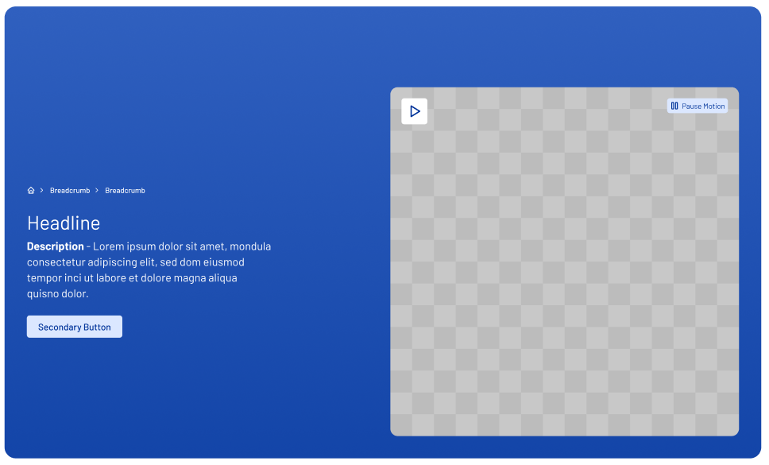

Headline:
Description:
Secondary Button Label:
Secondary Button Link Destination:
Image Source:  Image/asset/ Video File Naming Convention: [page name-asset name] | [Insert the details ]  name/title of content/graphic : URL/hyperlink to the content/graphic  [If it is new content/graphic – save the content in the Asset folder for your SME group
Image Alt Text: | (optional)

Anchor link (X1 Inline Navigation)
Link number | Link Label | Link Destination
1.
2.
3.
4.
5.
6.

Module 10 - M6 Icon Pillars
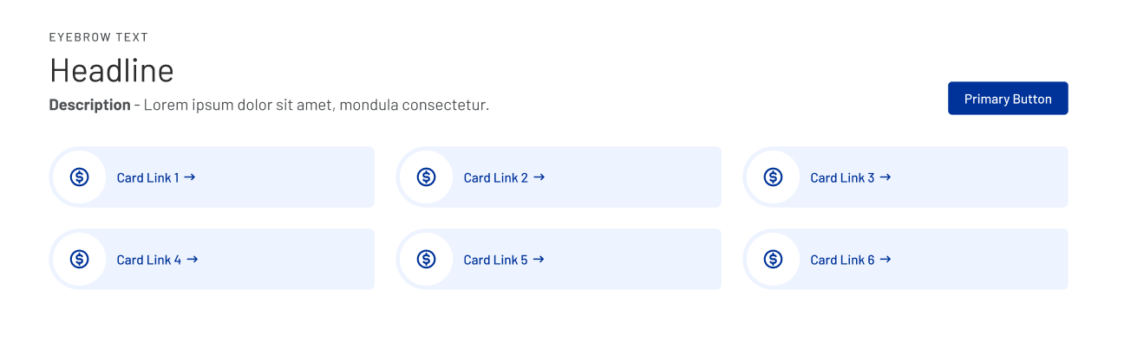

Headline:
Description:
Primary Button Label:
Button Link:
 | Card/s Headline | Card Description | URL Destination
1
2
3
4
5
6

Module 6 - M8 Alternating Content Block
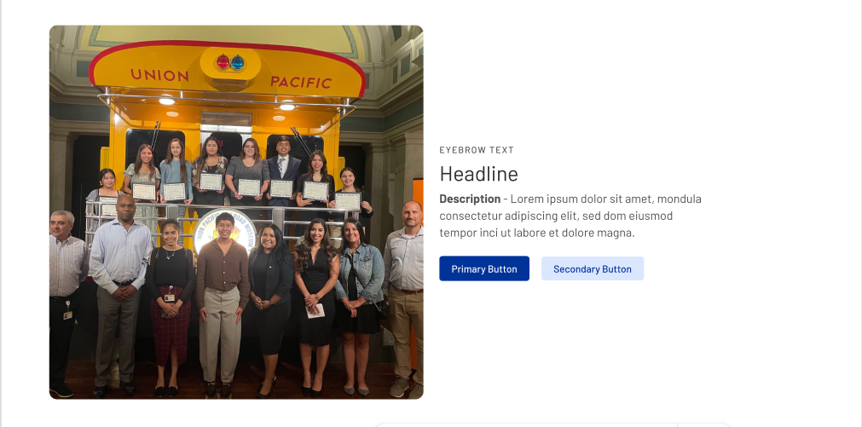

Headline:
Description:
Eyebrow Text:
Primary Button Label:
Primary Button Link Destination:
Secondary Button Label:
Secondary Button Link Destination:

Image Source:  Image/asset/ Video File Naming Convention: [page name-asset name] | [Insert the details ]  name/title of content/graphic : URL/hyperlink to the content/graphic  [If it is new content/graphic – save the content in the Asset folder for your SME group
Image Alt Text: | (optional)

Module 4 - M7 Feature Cards
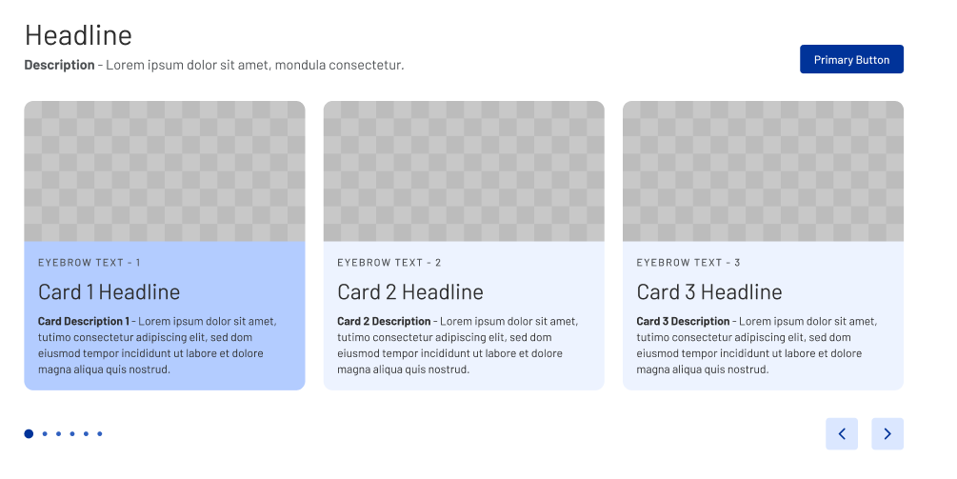

Headline
Description:
Primary Button Label:
Button Link Destination:

No. | Card Headline | Description | Eyebrow Text | Image Source | Image Alt Text: (optional)
1 |  |  |  | See image instructions on pg 1
2
3

